Assignment no.5
Stack
Course Name : Data Structures-I
Course Code : CS2301
Div : SEDA-B
Student Name : Yashraj Dinesh Hande
Roll Number : 18
Date of Submission : 24/11/2025

stack (Theory)
A stack is a linear data structure that follows the LIFO (Last In First Out) rule — the last element inserted is the first to be removed.
The two main operations are Push (insert an element) and Pop (remove the top element).
Stacks can be implemented using either arrays (fixed size) or linked lists (dynamic size).
They are essential in expression evaluation, function call management, undo-redo systems, and syntax checking.
📘 Applications in Practicals
- Stock Price Tracker: Uses a linked-list stack to record and remove daily stock prices.
- Infix to Postfix Conversion: Converts algebraic expressions using a stack to handle operator precedence.
- Multiple Stacks: Implements more than two stacks within one array to manage separate datasets.
- Balanced Parentheses Checker: Uses a stack to ensure all opening brackets have matching closing brackets.
- Postfix Expression Evaluation: Computes the result of postfix (Reverse Polish Notation) expressions using stack operations.
⚙️ Key Features
- Efficient data management with simple operations.
- Supports recursion, backtracking, and parsing.
- Fundamental for compiler design, expression solving, and memory management.

Problem 1 : WAP to build a simple stock price tracker that keeps a history of daily stock prices entered by the user. To allow users to go back and view or remove the most recent price, implement a stack using a linked list to store these integer prices.
Implement the following operations:
- record(price) – Add a new stock price (an integer) to the stack.
- remove() – Remove and return the most recent price (top of the stack).
- latest() – Return the most recent stock price without removing it.
- isEmpty() – Check if there are no prices recorded.
Code :
#include <iostream>
using namespace std;

// Node structure for stack
class Node {
public:
int price;
Node* next;

Node(int p) {
price = p;
next = NULL;
}
};

// Stack implemented using linked list
class StockStack {
private:
Node* top; // points to the top of the stack

public:
StockStack() {
top = NULL;
}

// 1. record(price) – Add a new stock price
void record(int price) {
Node* newNode = new Node(price);
newNode->next = top;
top = newNode;
cout << " Recorded stock price: " << price << endl;
}

// 2. remove() – Remove and return the most recent price
void remove() {
if (isEmpty()) {
cout << " No stock prices to remove.\n";
return;
}
Node* temp = top;
cout << " Removed most recent price: " << temp->price << endl;
top = top->next;
delete temp;
}

// 3. latest() – Return most recent stock price
void latest() {
if (isEmpty()) {
cout << " No stock prices recorded yet.\n";
return;
}
cout << " Latest recorded stock price: " << top->price << endl;
}

// 4. isEmpty() – Check if stack is empty
bool isEmpty() {
return (top == NULL);
}

// Display all recorded prices
void display() {
if (isEmpty()) {
cout << " No stock prices recorded.\n";
return;
}

cout << " Stock Price History (most recent first): ";
Node* temp = top;
while (temp != NULL) {
cout << temp->price;
if (temp->next != NULL)
cout << " -> ";
temp = temp->next;
}
cout << endl;
}
};

// ================= MAIN FUNCTION =================
int main() {
StockStack tracker;
int choice, price;

cout << "============================================\n";
cout << " STOCK PRICE TRACKER USING STACK (LINKED LIST)\n";
cout << "============================================\n";

do {
cout << "\n------ MENU ------\n";
cout << "1. Record new stock price\n";
cout << "2. Remove most recent price\n";
cout << "3. View latest price\n";
cout << "4. Check if stack is empty\n";
cout << "5. Display price history\n";
cout << "6. Exit\n";
cout << "Enter your choice: ";
cin >> choice;

switch (choice) {
case 1:
cout << "Enter stock price to record: ";
cin >> price;
tracker.record(price);
break;
case 2:
tracker.remove();
break;
case 3:
tracker.latest();
break;
case 4:
if (tracker.isEmpty())
cout << " No prices recorded (stack is empty).\n";
else
cout << " Prices are recorded (stack not empty).\n";
break;
case 5:
tracker.display();
break;
case 6:
cout << "Exiting program... Thank you!\n";
break;
default:
cout << " Invalid choice! Try again.\n";
}
} while (choice != 6);

return 0;
}

Output :
PS C:\Users\yashraj\Desktop\DSA with C++> cd "c:\Users\yashraj\Desktop\DSA with C++\Assignment 5\" ; if ($?) { g++ problem1.cpp -o problem1 } ; if ($?) { .\problem1 }
============================================
STOCK PRICE TRACKER USING STACK (LINKED LIST)
============================================

------ MENU ------
1. Record new stock price
2. Remove most recent price
3. View latest price
4. Check if stack is empty
5. Display price history
6. Exit
Enter your choice: 1
Enter stock price to record: 5000
Recorded stock price: 5000

------ MENU ------
1. Record new stock price
2. Remove most recent price
3. View latest price
4. Check if stack is empty
5. Display price history
6. Exit
Enter your choice: 1
Enter stock price to record: 6000
Recorded stock price: 6000

------ MENU ------
1. Record new stock price
2. Remove most recent price
3. View latest price
4. Check if stack is empty
5. Display price history
6. Exit
Enter your choice: 3
Latest recorded stock price: 6000

------ MENU ------
1. Record new stock price
2. Remove most recent price
3. View latest price
4. Check if stack is empty
5. Display price history
6. Exit
Enter your choice: 4
Prices are recorded (stack not empty).

------ MENU ------
1. Record new stock price
2. Remove most recent price
3. View latest price
4. Check if stack is empty
5. Display price history
6. Exit
Enter your choice: 2
Removed most recent price: 6000

------ MENU ------
1. Record new stock price
2. Remove most recent price
3. View latest price
4. Check if stack is empty
5. Display price history
6. Exit
Enter your choice: 4
Prices are recorded (stack not empty).

------ MENU ------
1. Record new stock price
2. Remove most recent price
3. View latest price
4. Check if stack is empty
5. Display price history
6. Exit
Enter your choice: 5
Stock Price History (most recent first): 5000

------ MENU ------
1. Record new stock price
2. Remove most recent price
3. View latest price
4. Check if stack is empty
5. Display price history
6. Exit
Enter your choice: 2
Removed most recent price: 5000

------ MENU ------
1. Record new stock price
2. Remove most recent price
3. View latest price
4. Check if stack is empty
5. Display price history
6. Exit
Enter your choice: 5
No stock prices recorded.

------ MENU ------
1. Record new stock price
2. Remove most recent price
3. View latest price
4. Check if stack is empty
5. Display price history
6. Exit
Enter your choice: 6
Exiting program... Thank you!
PS C:\Users\yashraj\Desktop\DSA with C++\Assignment 5>

Problem 2 : Convert given infix expression Eg. a-b*c-d/e+f into postfix form using stack and show the operations step by step.
Code:
# #include <iostream>
#include <stack>
#include <string>
using namespace std;

// Function to return precedence of operators
int precedence(char op) {
if (op == '+' || op == '-')
return 1;
if (op == '*' || op == '/')
return 2;
return 0;
}

// Function to check if character is an operator
bool isOperator(char c) {
return (c == '+' || c == '-' || c == '*' || c == '/');
}

// Convert infix to postfix and display steps
string infixToPostfix(string infix) {
stack<char> s;
string postfix = "";

cout << "\n--- Step-by-Step Conversion ---\n";
cout << "Symbol\tStack\t\tPostfix\n";
cout << "----------------------------------------\n";

for (char c : infix) {
// Operand → directly add to postfix
if (isalnum(c)) {
postfix += c;
}

// Opening parenthesis → push to stack
else if (c == '(') {
s.push(c);
}

// Closing parenthesis → pop until '('
else if (c == ')') {
while (!s.empty() && s.top() != '(') {
postfix += s.top();
s.pop();
}
s.pop(); // Remove '('
}

// Operator
else if (isOperator(c)) {
while (!s.empty() && precedence(s.top()) >= precedence(c)) {
postfix += s.top();
s.pop();
}
s.push(c);
}

// Print current step
cout << c << "\t";
// Display stack contents
stack<char> temp = s;
string stContent = "";
while (!temp.empty()) {
stContent = temp.top() + stContent;
temp.pop();
}
cout << stContent << "\t\t" << postfix << endl;
}

// Pop remaining operators
while (!s.empty()) {
postfix += s.top();
s.pop();
}

cout << "----------------------------------------\n";
return postfix;
}

int main() {
string infix;
cout << "===========================================\n";
cout << " INFIX TO POSTFIX CONVERSION USING STACK\n";
cout << "===========================================\n";

cout << "Enter infix expression (e.g. a-b*c-d/e+f): ";
cin >> infix;

string postfix = infixToPostfix(infix);

cout << "\n Final Postfix Expression: " << postfix << endl;
return 0;
}

OUTPUT :
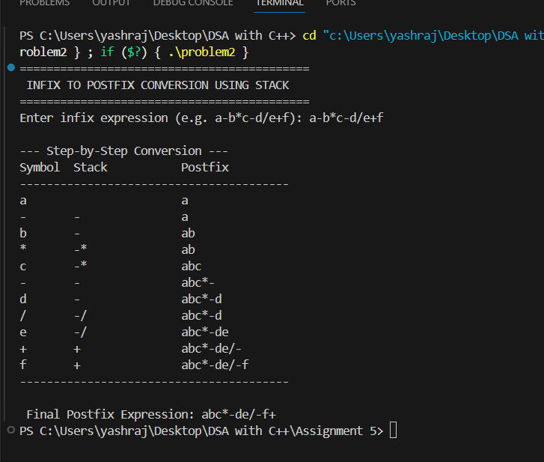
Problem 3 : Write a program to implement multiple stack i.e more than two stack using array and perform following operations on it. A. Push B. Pop C. Stack Overflow D. Stack Underflow E. Display
Code :
#include <iostream>
using namespace std;

#define MAX 50 // total array size

class MultiStack {
int arr[MAX];
int top[10]; // array of top indices for each stack
int start[10]; // starting index of each stack
int end[10]; // ending index of each stack
int n; // number of stacks

public:
MultiStack(int numStacks) {
n = numStacks;
int size = MAX / n; // divide array equally
for (int i = 0; i < n; i++) {
start[i] = i * size;
end[i] = (i + 1) * size - 1;
top[i] = start[i] - 1; // initially empty
}
}

void push(int stackNum, int value) {
if (top[stackNum] == end[stackNum]) {
cout << "Stack Overflow in Stack " << stackNum + 1 << endl;
return;
}
top[stackNum]++;
arr[top[stackNum]] = value;
cout << "Pushed " << value << " into Stack " << stackNum + 1 << endl;
}

void pop(int stackNum) {
if (top[stackNum] < start[stackNum]) {
cout << "Stack Underflow in Stack " << stackNum + 1 << endl;
return;
}
cout << "Popped " << arr[top[stackNum]] << " from Stack " << stackNum + 1 << endl;
top[stackNum]--;
}

void display(int stackNum) {
if (top[stackNum] < start[stackNum]) {
cout << "Stack " << stackNum + 1 << " is empty\n";
return;
}
cout << "Stack " << stackNum + 1 << " elements: ";
for (int i = start[stackNum]; i <= top[stackNum]; i++)
cout << arr[i] << " ";
cout << endl;
}
};

int main() {
int n;
cout << "Enter number of stacks: ";
cin >> n;

MultiStack ms(n);
int choice, stackNum, value;

do {
cout << "\n--- Multiple Stack Operations ---\n";
cout << "1. Push\n2. Pop\n3. Display\n4. Exit\n";
cout << "Enter your choice: ";
cin >> choice;

switch (choice) {
case 1:
cout << "Enter stack number (1 to " << n << "): ";
cin >> stackNum;
cout << "Enter value: ";
cin >> value;
ms.push(stackNum - 1, value);
break;

case 2:
cout << "Enter stack number (1 to " << n << "): ";
cin >> stackNum;
ms.pop(stackNum - 1);
break;

case 3:
cout << "Enter stack number (1 to " << n << "): ";
cin >> stackNum;
ms.display(stackNum - 1);
break;

case 4:
cout << "Exiting...\n";
break;

default:
cout << "Invalid choice!\n";
}

} while (choice != 4);

return 0;
}

OUTPUT:
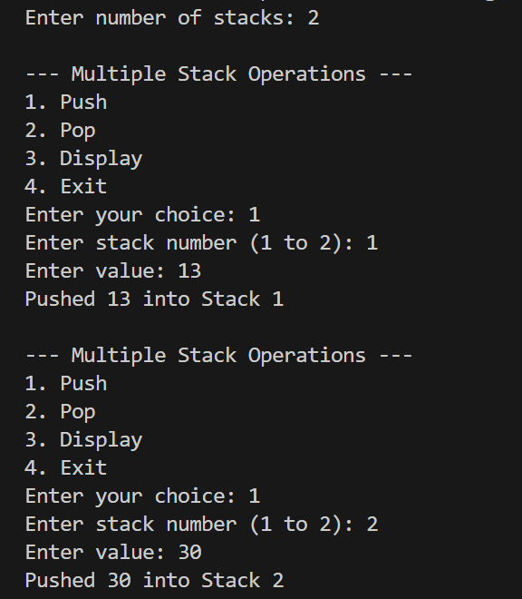
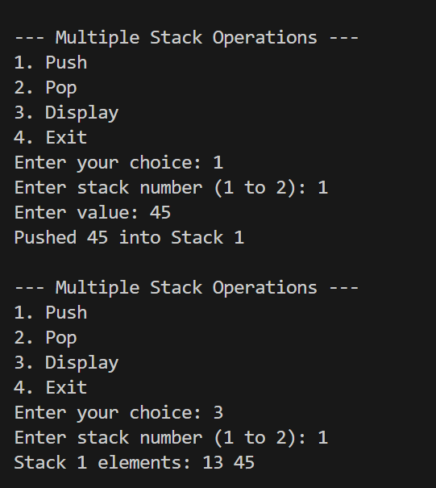
Problem 4 :
You are given a string containing only parentheses characters: '(', ')', '{', '}', '[', and ']'. Your task is to check whether the parentheses are balanced or not.
A string is considered balanced if:
- Every opening bracket has a corresponding closing bracket of the same type
- Brackets are closed in the correct order.
CODE :
#include <iostream>
#include <stack>
using namespace std;

// Function to check if brackets are balanced
bool isBalanced(string s) {
stack<char> st;
for (char ch : s) {
// Push opening brackets
if (ch == '(' || ch == '{' || ch == '[') {
st.push(ch);
}
else {
// If stack empty → no matching opening bracket
if (st.empty())
return false;
char top = st.top();
st.pop();

// Check matching pair
if ( (ch == ')' && top != '(') ||
(ch == '}' && top != '{') ||
(ch == ']' && top != '[') ) {
return false;
}
}
}
// If stack is empty → balanced
return st.empty();
}
int main() {
string expr;
cout << "Enter expression: ";
cin >> expr;
if (isBalanced(expr))
cout << "Balanced";
else
cout << "Not Balanced";

return 0;
}

OUTPUT :

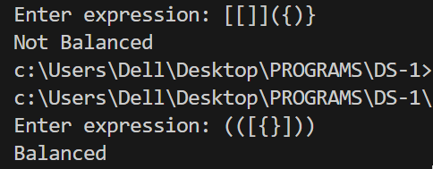
Problem 5 : You are given a postfix expression (also known as Reverse Polish Notation) consisting of single-digit operands and binary operators (+, -, *, /). Your task is to evaluate the expression using stack and return its result.
CODE :
#include <iostream>
#include <stack>
using namespace std;

// Function to evaluate postfix expression
int evaluatePostfix(string exp) {
stack<int> st;

for (char ch : exp) {
// If operand (0-9), push to stack
if (isdigit(ch)) {
st.push(ch - '0'); // Convert char to int
}
else {
// Operator: pop top two elements
int val2 = st.top(); st.pop();
int val1 = st.top(); st.pop();
int result;

// Perform operation
switch (ch) {
case '+': result = val1 + val2; break;
case '-': result = val1 - val2; break;
case '*': result = val1 * val2; break;
case '/': result = val1 / val2; break;
}

// Push result back
st.push(result);
}
}

// Final result on top of stack
return st.top();
}

int main() {
string exp;
cout << "Enter postfix expression: ";
cin >> exp;

cout << "Result = " << evaluatePostfix(exp);

return 0;
}

OUTPUT :

